*Logic Specification Template*

|  |  |  |  |
| --- | --- | --- | --- |
| **Student** | Lucía Cantú-Miller | **Program #** | 5 |

|  |  |
| --- | --- |
| **Class Name** | Simpson |

|  |  |
| --- | --- |
| **Method Name** | SimpsonRule |

|  |  |
| --- | --- |
| **Parameters** |  |
|  |  |

**Include the image of the activity diagram created for the program:**

|  |  |
| --- | --- |
| **Class Name** | Simpson |

|  |  |
| --- | --- |
| **Method Name** | CalculateDiference |

|  |  |
| --- | --- |
| **Parameters** |  |
|  |  |

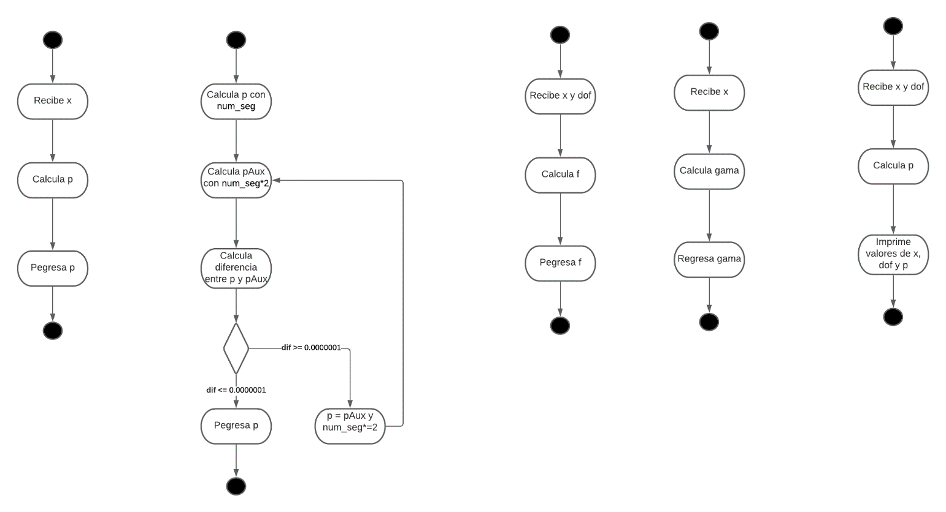

**Include the image of the activity diagram created for the program:**

|  |  |
| --- | --- |
| **Class Name** | Simpson |

|  |  |
| --- | --- |
| **Method Name** | getSimpson |

|  |  |
| --- | --- |
| **Parameters** | x |
|  | dof |

**Include the image of the activity diagram created for the program:**

|  |  |
| --- | --- |
| **Class Name** | Distribution |

|  |  |
| --- | --- |
| **Method Name** | Dist |

|  |  |
| --- | --- |
| **Parameters** | x |
|  | dof |

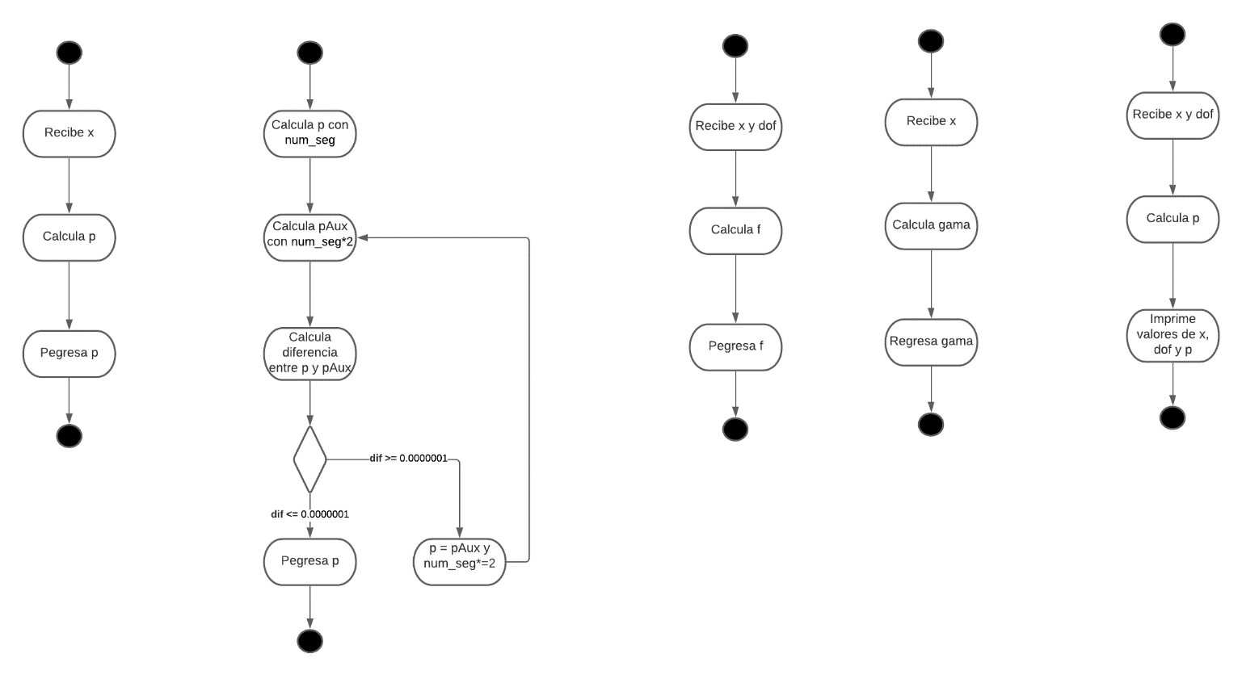

**Include the image of the activity diagram created for the program:**

|  |  |
| --- | --- |
| **Class Name** | Distribution |

|  |  |
| --- | --- |
| **Method Name** | Gamma |

|  |  |
| --- | --- |
| **Parameters** | x |
|  |  |

**Include the image of the activity diagram created for the program:**

|  |  |
| --- | --- |
| **Class Name** | Main |

|  |  |
| --- | --- |
| **Method Name** | Main |

|  |  |
| --- | --- |
| **Parameters** |  |
|  |  |

Por medio de este párrafo yo Lucía Cantú-Miller certifico que soy el autor intelectual del material que arriba entrego y que no realicé una copia de ninguna otra persona. En aquellos casos en los que tuve que incluir material de otra persona, reporté su apropiada referencia.